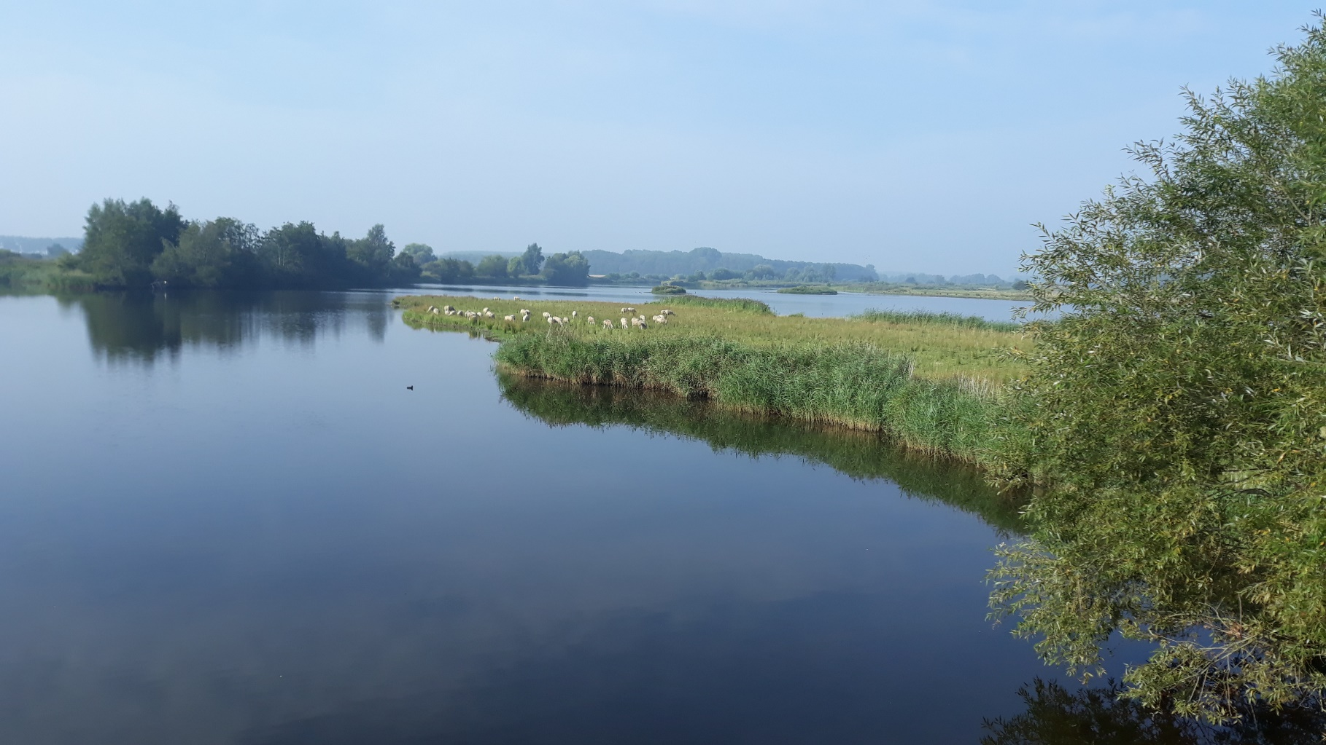

|  |
| --- |
|  |

Water quality and quantity

Fresh water sources for infiltration in the Braakman-Zuid area



HZ Water Technology

25-07-2022

**WATER QUALITY AND QUANTITY**

Fresh water sources for infiltration in the Braakman-Zuid area

B. Letterie

HZ Water Technology  
  
25-07-2022  
Middelburg  
Version 1.1  
Concept report

This report is written by HZ Watertechnology

**Inhoudsopgave**

1. Introduction 3

1.1 FRESH4Cs 3

1.2 Overview of The area 3

2. Methodology 6

2.1 Isabellakanaal 6

2.2 Leopoldkanaal 7

2.3 Zwarte Sluidpolder and Isabellapolder 7

3. Results and discussion 8

3.1 Water quality 8

3.1.1 Isabellakanaal 8

3.1.2 Leopoldkanaal 9

3.1.3 Zwarte Sluispolder and Isabellapolder 10

3.2 Water quantity 11

4. Conclusions 13

5. recommendations 14

Refferences 15

I. Water quality data 16

II. Volume over the Boekhoute weir 17

III. Calculations Volume over Boekhoute Weir 19

# Introduction

In this chapter the project FRESH4Cs, the purpose of this report and the area where the project is taking place is introduced.

1. FRESH4Cs

The FRESH4Cs project focusses on the second Europe 2020 priority of sustainable growth, by demonstrating the provision of alternative and sustainable fresh water resources for lowland coastal regions. Traditional water resources are under pressure, and this problem is even more prominent in lowland coastal regions due to salinization of (near) surface waters. These same coastal lowlands drain vast amounts of water towards the sea at moments of water surplus (seasonal). Where water consumption has often been reduced to economic feasible levels, a second step in efficient water resource management is providing alternative and more sustainable resources, which is the focus of this project.

Dow is a partner in the FRESH4Cs project and the aim for Dow is to become resilient to climate change and independent of remote fresh water supply originating from the Biesbosch, 120 km away. Therefore Dow actively works on water savings, recycling and multi-sourcing. In 2008 the concept of a Robust Water System in the area of Zeeuws-Vlaanderen was initiated. It pursues collaborations with local governments and other end users in industry and agriculture to find regional solutions. DOW has invested over the past years in this robust water system for the region, not only in providing for its own water resources but also in aiding other regional water users.

In the current project there is an interest in exploring underground fresh water storage capabilities within the Braakman South region (cross-border Netherlands/Belgium). Excess rain precipitating in winter months, can be captured and temporarily stored for usage by agriculture and industry during periods of shortage. Dow would benefit from such a feasibility study, as it might provide solutions for its own water resources. Additionally, it will also strengthen Dow’s cooperation with other regional water users that will benefit directly from the project (mainly farmers).

This report is written under work package 3 of the project, where Dow is preparing for investments, articulating the volumes and quality of water to be supplied to Dow and local farmers. In this report the water quality and water quantity of water sources in the area will be examined for suitability for infiltration.

1. Overview of The area

The Dow production facility Terneuzen is located in Zeeuws-Vlaanderen close to the Braakman, a diverse area with nature, water, tourism, agriculture and basins for drinking and process water supply. An overview of the area is show in Figure 1. In the figure the Dow production facility is indicated as 1, the water basins, owned and maintained by Evides (Drinking and process water company) is indicated as 2. There are three basins in total, one basin filled with solely Biesbosch water, and two filled with mainly water from the Belgium Zwarte Sluispolder and the Isabellapolder, shown as 3 in the map. In the next paragraphs the potential fresh water sources in the area will be introduced, respectively the water from the Belgium Zwarte Sluispolder and Isabellapolder, the Isabellakanaal and the Leopoldkanaal. An overview of the locations of the potential fresh water sources is shown in Figure 4.

The water of the Belgium polders come together in a ditch and is discharged over the Boekhoute weir towards the Leopoldkanaal. The water from the Leopoldkanaal finally flows gravitationally towards Zeebrugge into the North Sea where it is mixed with the sea water. A picture of the Broekhoute weir is shown in Figure 2. Evides has a pumping station upstream of the weir from where the water is being pumped via a subsoil pipeline until across the border with the Netherlands, where the water is discharged into an open concrete channel which is called the rigool”. The rigool is indicated in blue in Figure 1 and a

|  |  |
| --- | --- |
| Figure 1: The Braakman area, 1: Dow, 2: Basins, 3: Polders | picture of the rigool is shown in Figure 3. The water is gravitationally discharged via the rigool to the basins where it is stored. The Isabellakanaal starts at the Belgium border at the Isabellagemaal and discharges water into the Braakmankreek. The Braakmankreek finally discharges into the Western Scheldt. The Isabellakanaal is indicated with the most northern arrow in Figure 4, the Leopoldkanaal with the arrow below and the polders with the most southern arrow. The Leopoldkanaal originates near Assenede and flows Westwards to Zeebrugge where is runs off into the North Sea. The channel has a length of 46 km and a weir is installed near Sint Laureins preventing salt water from the North Sea flowing further Eastwards. The Leopoldkanaal is connected to the Isabellakanaal via the Isabellagemaal, a pumping station located at the border. An overview of all the channels and weirs is shown in Figure 5. Under normal circumstances the water flows gravitationally to the North Sea but also to the Isabellakanaal. When the water levels in the Leopoldkanaal become too high the Isabellagemaal pumps the water into the Isabellakanaal. However, in 2015 the Dutch waterboard increased the water level in the Isabellakanaal with 50 cm during the winter period, from -0.90 m NAP to -0.40 m NAP, meaning that the Isabellakanaal from that moment on has a fixed water level of -0.4 m NAP (*Waterschap Scheldestromen, 2015).* This increase of the water level makes it not possible anymore for the water from the Leopoldkanaal to gravitationally flow into the Isabellakanaal and the water from the Leopoldkanaal now only flows into the Isabellakanaal occasionally when the water level of the Leopoldkanaal becomes too high and the pumps are switched on. The reduced amount of freshwater flowing from the Leopoldkanaal to the Isabellakanaal makes it plausible that the chloride concentration of the Isabellakanaal has increased compared to the situation before 2015, when the chloride concentration was determined to fluctuate between 100 and 300 mg/l (*Waterschap Scheldestromen, 2015*). |
| A picture containing sky, outdoor, building, bridge  Description automatically generated  Figure : Koekhoute weir |
| Figure 3: Open water channel "rigool" |

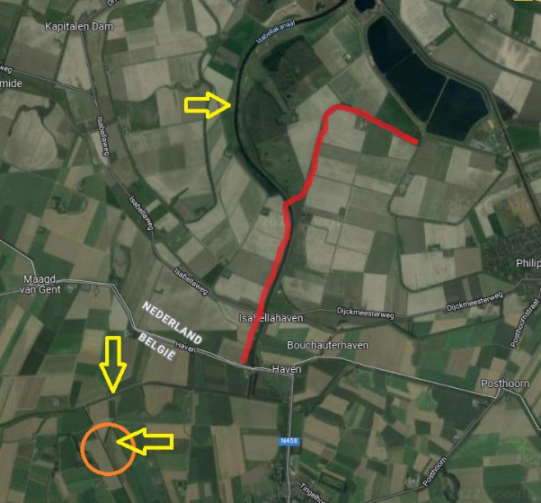

Figure 4: Potential fresh water sources

Figure 5: Overview of channels and weirs

# Methodology

In this chapter the methodology used to examine the suitability regarding both the water quality and the water quantity of the three potential fresh water sources will be described.

1. Isabellakanaal

The Isabellakanaal receives less fresh water from the Belgium polders since 2015 and therefore it is plausible that the chloride concentration of the Isabellakanaal has become too high over the past few years to be used for infiltration. Therefore the water quality was first tested on electrical conductivity (EC), a substitute for the chloride concentration.

For the duration of one year, starting on September 2020 until august 2021, the EC has been measured on a monthly basis on different locations along the Isabellakanaal starting at the Braakman and following the channel until past the Isabella gemaal, just across the Belgium border. An overview of the different measuring locations is shown in Figure 6. An overview of the coordinates of the measuring locations is shown in Table 1.

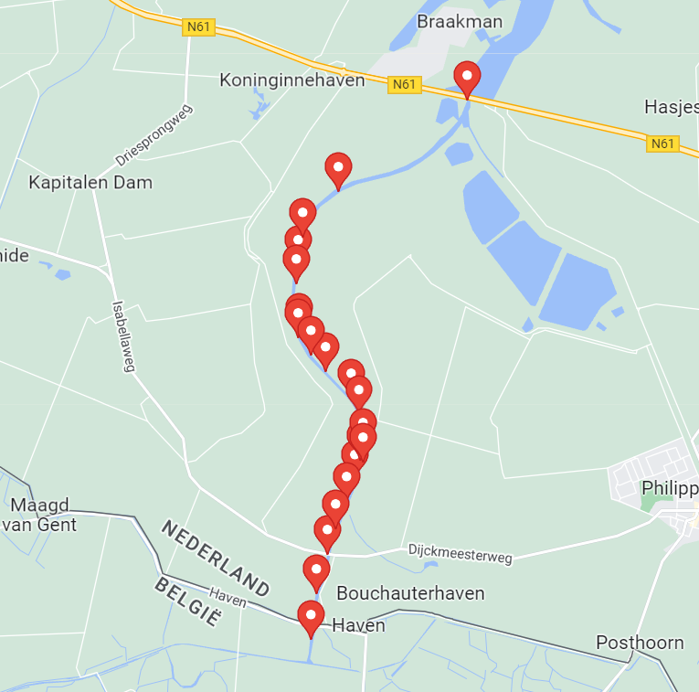

Figure 6: Measuring location Isabellakanaal

Table 1: Coordinates locations Isabellakanaal

|  |  |  |
| --- | --- | --- |
| Meetlocatie: | Lat: | Lon: |
| 0 | 51°18'47.6"N | 3°43'53.7"E |
| 1 | 51°18'22.1"N | 3°42'55.4"E |
| 2 | 51°18'14.9"N | 3°42'44.5"E |
| 3 | 51°18'09.2"N | 3°42'39.6"E |
| 4 | 51°18'01.3"N | 3°42'37.4"E |
| 5 | 51°17'55.9"N | 3°42'36.5"E |
| 6 | 51°17'42.3"N | 3°42'37.9"E |
| 7 | 51°17'35.8"N | 3°42'43.1"E |
| 8 | 51°17'31.3"N | 3°42'49.8"E |
| 9 | 51°17'23.8"N | 3°43'01.3"E |
| 10 | 51°17'19.1"N | 3°43'04.8"E |
| 11 | 51°17'09.8"N | 3°43'06.8"E |
| 12 | 51°17'06.2"N | 3°43'05.3"E |
| 13 | 51°17'00.8"N | 3°43'03.0"E |
| 14 | 51°16'54.6"N | 3°42'59.2"E |
| 15 | 51°16'46.9"N | 3°42'54.5"E |
| 16 | 51°16'39.7"N | 3°42'50.5"E |
| 17 | 51°16'28.8"N | 3°42'45.7"E |
| 18 | 51°16'20.4"N | 3°42'44.9"E |
| 19 | 51°16'15.7"N | 3°42'43.3"E |

Based on the results of the EC measurements and the calculated chloride concentrations which will be described in the chapter results, it will be determined if the water is fresh enough for infiltration. Depending on the results it will be decided if the other water quality parameters will also be measured to conclude if the water quality of the Isabellakanaal is suitable for infiltration.

1. Leopoldkanaal

To determine the water quality parameters that are relevant for infiltration into the groundwater the Nota Grondwater is applicable (*Waterschap Scheldestromen, 2019*). The water quality of the Leopoldkanaal has been determined by the external laboratory Aqualab Zuid B.V., accredited conform NEN-EN-ISO/IEC 17025 (nl) under the number L387. The analysis have been performed conform NEN 6600-2, in compliance with the Nota Grondwater. The parameters that have been monitored have been discussed with the waterboard Waterschap Scheldestromen and are mostly in line with the Nota Grondwater. WSSS has agreed with deviating slightly from the Nota Grondwater regarding the list of pesticides and herbicides since the monitoring of the water quality regarding pesticides and herbicides was already ongoing for several years on the water coming from the Belgium Zwarte Sluispolder and the Isabellapolder by Evides, and measuring the same parameters on the Leopoldkanaal enabled us to make a solid comparison while still taking the major pesticides and herbicides into account.

1. Zwarte Sluidpolder and Isabellapolder

Also for the Zwarte Sluispolder and for the Isabellapolder the water quality has been determined by Aqualab Zuid B.V. The water samples have been taken from the Evides basins whose are only fed by water coming from both polders. The same parameters have been analysed as for the Leopoldkanaal.

Of both the Zwarte Sluispolder and the Isabellapolder, an analysis has been done how much water would potentially be available for infiltration. The water of both polders comes together in a ditch and is discharged over the Boekhoute weir towards the Leopoldkanaal. The water from the Leopoldkanaal finally flows into the Noth Sea where is is mixed with the sea water.

To calculate the volume of water that flows over the weir data from the Boekhoute weir has been used (*Vlaanderen Waterinfo Kaartencatalogus*). The data provides information about the water level upstream of the weir and of the level of the weir itself, both TAW corrected. By using the Rehbock formula (Boiten *et al*., 1995) the flowrate over the weir can be calculated. The data at the Boekhoute weir is logged every 15 minutes which makes it possible to calculate the volume that flows over the weir for every quarter of an hour. Finally the volume has been calculated on a monthly basis.

# Results and discussion

In this chapter the results of the measurements of the water quality will be presented and compared with the thresholds mentioned in the Nota Grondwater. Also the calculated water quantities will be presented and discussed.

1. Water quality

The water quality of the Isabellakanaal, the Leopoldkanaal and the water from the Evides basins that comes from the Belgium Zwarte Sluispolder and the Isabellapolder has been measured and analysed. In the next subchapter the water quality analysis of the three possible sources of freshwater will be presented. The raw data and the processed data can be found in Appendix I.

1. Isabellakanaal

For the Isabellekanaal the water quality was first tested on electrical conductivity (EC), a substitute for the chloride concentration. In the Nota Grondwater, a threshold for chloride for infiltration in groundwater is stated of 160 mg/l. Also the Nota Grondwater states formula (1) and (2) for converting EC into the of concentration chloride in mg/l.

EC < 4mS/cm / Cl < 1000 mg/l: EC = (Cl + 188.5) / 286 (1)

EC > 4mS/cm / Cl > 1000 mg/l: EC = (Cl + 450) / 360 (2)

Using formula (1) it is determined that an upper threshold of 1.22 mS/cm can be used, all values below the threshold represent chloride concentrations lower than 160 mg/l. The results of the EC measurements at the different location is shown in Figure 7.

Figure 7: EC measurements Isabellakanaal

From Figure 7 it can be derived that only on February the 5th from location 10 to the Belgium border the EC was sufficiently low to meet the threshold for chloride of 160 mg/l. All other measurements show an exceedance of the norm for chloride. This would mean that the Isabellakanaal can only provide fresh water for infiltration during a very limited timeframe of the year.

1. Leopoldkanaal

The results of the analysis of the water quality of the Leopoldkanaal are shown in Table 2

Table 2: Results water quality analysis Leopoldkanaal

|  |  |  |  |  |  |  |  |  |
| --- | --- | --- | --- | --- | --- | --- | --- | --- |
| **Parameter** | **Unit** | **Nota Grond- water** | **2-11-2021** | **6-12-2021** | **3-1-2022** | **7-2-2022** | **7-3-2022** | **4-4-2022** |
| Chloride (Cl-) | mg/L | 160 | 140 | 150 | 290 | 130 | 160 | 1000 |
| Total Phosphorous | mg/L-P | 2 | 0,49 | 0,49 | 0,44 | 0,69 | 0,25 | 0,25 |
| Nitrate (NO3-) | mg/L-N | 50 | 12 | 26 | 21 | 21 | 26 | <0,2 |
| Arsenic (As) | µg/L | 13,2 | 2,2 | 2,5 | 2,4 | 3,2 | 1,2 | 4,2 |
| Cadmium (Cd) | µg/L | 0,35 | <0.2 | <0,2 | <0,2 | <0,2 | <0,2 | <0,2 |
| Copper (Cu)* | µg/L | 2,4 | <5 | 5,1 | <5 | 5,1 | <5 | <5 |
| Lead (Pb) | µg/L | 7,4 | <1 | 1,4 | <1 | 4,6 | <1 | <1 |
| Manganese (Mn)* | µg/L | 31 | 380 | 150 | 190 | 160 | 220 | 130 |
| Nickel (Ni) | µg/L | 20 | 2,3 | 2,9 | 2,6 | 3,5 | 2,1 | 2,1 |
| Total sum of Pesticides** | µg/L | 0,5 | 1,43 | 0,96 | 0,83 | 0,75 | 0,80 | 0,80 |
| Naphthalene | µg/L | 0,01 | <0.05 | <0,05 | <0,05 | <0,05 | <0,05 | <0,05 |
| Anthracene | µg/L | 0,0007 | <0.005 | <0,005 | <0,005 | <0,005 | <0,005 | <0,005 |
| Phenanthrene | µg/L | 0,003 | <0.005 | 0,0096 | <0,005 | 0,0091 | 0,0056 | <0,005 |
| Crysene | µg/L | 0,003 | <0.005 | <0,005 | <0,005 | <0,005 | <0,005 | <0,005 |
| Fluoranthene | µg/L | 0,003 | <0.005 | <0,005 | <0,005 | 0,0056 | <0,005 | <0,005 |
| Benzo (a) anthracene | µg/L | 0,0001 | <0.005 | <0,005 | <0,005 | <0,005 | <0,005 | <0,005 |
| Benzo (k) fluoranthene | µg/L | 0,0004 | <0.005 | <0,005 | <0,005 | <0,005 | <0,005 | <0,005 |
| Benzo (a) pyrene | µg/L | 0,0005 | <0.005 | <0,005 | <0,005 | <0,005 | <0,005 | <0,005 |
| Benzo (ghi) perylene | µg/L | 0,0003 | <0.005 | <0,005 | <0,005 | <0,005 | <0,005 | <0,005 |
| Indeno (123cd) pyrene | µg/L | 0,0004 | <0.005 | <0,005 | <0,005 | <0,005 | <0,005 | <0,005 |
| * Only for biological agriculture  **If the sum is exceeded, a threshold of 0.1 µg/l for the individual substances are applicable | | | | | | | | |

The chloride concentration of the Leopoldkanaal is mainly in compliance with the threshold of 160 mg/l as described in the Nota Grondwater. During the infiltration the EC will be continuously monitored and when the threshold is exceeded, the infiltration will be stopped if water the Leopoldkanaal would be used.

For the metals, cupper exceeds the upper limit in two of the six measurements, and manganese is structurally to high. For both cupper and manganese, the norm is only applicable if the water will be used for biological agriculture. Since it is assumable that one of the potential farmers will practice biological agriculture, it is desirable that both cupper and manganese meet the threshold mentioned in the Nota Grondwater if water of the Leopoldkanaal would be used for infiltration.

Also for the total sum of pesticides, the values structurally exceed the threshold of 0.5 µg/l. Conform the Nota Grondwater, the individual pesticides have been analysed and it was concluded that 2,6-Dichlorobenzamide (BAM), Glyphosate (commonly used in Roundup and nowadays also in other brands) and Aminomethylphosphonic acid (AMPA, a breakdown product of glyphosate) exceed the threshold of 0.1 µg/l for all analysis. For infiltration the pesticides are too high if water from the Leopoldkanaal would be used.

For the polycyclic aromatic hydrocarbons (PACs) phenanthrene exceeds the threshold in three out of 6 analysis. Phenanthrene is released by burning hydrocarbons like natural gas and gasoline, and is considered to be carcinogenic. Also one analysis showed an exceedance of fluoranthene. For both phenanthrene and fluoranthene the limit for drinking water is 0.1 µg/L (*RIVM Zoeksysteem van stoffen, 2022*). It can be assumed that there is no health risk involved when water from the Leopoldkanaal is used for infiltration, but to avoid accumulation of the PACs in the groundwater the limit as described in the Nota Grondwater will be followed meaning that the values for PACs are too high for infiltration when water from the Leopoldkanaal would be used.

1. Zwarte Sluispolder and Isabellapolder

The results of the water quality analysis of the Zwarte Sluispolder and the Isabellapolder are show in Table 3.

Table 3: Results water quality analysis Zwarte Sluispolder and Isabellapolder

|  |  |  |  |  |  |  |  |  |  |  |  |  |  |  |
| --- | --- | --- | --- | --- | --- | --- | --- | --- | --- | --- | --- | --- | --- | --- |
| **Parameter** | **Unit** | **Nota Grondwater** | **14-12-2020** | **18-1-2021** | **15-2-2021** | **15-3-2021** | **19-4-2021** | **17-5-2021** | **21-6-2021** | **15-11-2021** | **20-12-2021** | **17-1-2022** | **21-2-2022** | **21-3-2022** |
| Chloride (Cl-) | mg/L | 160 | 83 | 81 | 81 | 80 | 78 | 81 | 81 | 84 | 77 | 77 | 78 | 80 |
| Total Phosphorous | mg/L-P | 2 | 0,1 | 0,1 | 0,1 | 0,1 | <0,1 | <0,1 | <0,1 | 0,024 | 0,036 | <0,1 | <0,1 | <0,1 |
| Nitrate (NO3-) | mg/L-N | 50 | 3,2 | 6,4 | 6,1 | 6,4 | 28 | 25 | 21 | 13 | 20 | 26 | 26 | 24 |
| Arsenic (As) | µg/L | 13,2 | 1 | 1 | 1 | 1 | <1 | <1 | <1 | <1 | <1 | <1 | <1 | <1 |
| Cadmium (Cd) | µg/L | 0,35 | 0,2 | 0,2 | 0,2 | 0,2 | <0,2 | <0,2 | <0,2 | <0,2 | <0,2 | <0,2 | <0,2 | <0,2 |
| Copper (Cu)* | µg/L | 2,4 | 5 | 5 | 5 | 5,1 | <0,005 | <0,005 | <0,005 | <0,005 | <0,005 | <0,005 | <0,005 | 0 |
| Lead (Pb) | µg/L | 7,4 | 1 | 1 | 1 | 1 | <1 | <1 | <1 | <1 | <1 | <1 | <1 | <1 |
| Manganese (Mn)* | µg/L | 31 | 25 | 63 | 62 | 60 | <10 | <10 | 13 | 52 | 82 | 98 | 78 | 63 |
| Nickel (Ni) | µg/L | 20 | 2 | 2,2 | 2,1 | 2,5 | 2,0 | 2,3 | 2,1 | 2,1 | 2,5 | 2,6 | 2,1 | 2,4 |
| Total sum of Pesticides** | µg/L | 0,5 | 0,677 | 0,024 | 0,493 | 0,67 | 0,691 | 0,63 | 0,37 | 1,085 | 1,242 | 0,635 | 0,613 | 0,598 |
| Naphthalene | µg/L | 0,01 | <0,05 | <0,05 | <0,05 | <0,05 | <0,05 | <0,05 | <0,05 | <0,05 | <0,05 | <0,05 | <0,05 | <0,05 |
| Anthracene | µg/L | 0,0007 | <0,005 | <0,005 | <0,005 | <0,005 | <0,005 | <0,005 | <0,005 | <0,005 | <0,005 | <0,005 | <0,005 | <0,005 |
| Phenanthrene | µg/L | 0,003 | 0,0064 | 0,0072 | 0,009 | 0,006 | <0,005 | <0,005 | <0,005 | 0,0052 | 0,007 | 0,0077 | 0,0062 | 0,0055 |
| Crysene | µg/L | 0,003 | <0,005 | <0,005 | <0,005 | <0,005 | <0,005 | <0,005 | <0,005 | <0,005 | <0,005 | <0,005 | <0,005 | <0,005 |
| Fluoranthene | µg/L | 0,003 | <0,005 | <0,005 | <0,005 | <0,005 | <0,005 | <0,005 | <0,005 | <0,005 | <0,005 | <0,005 | <0,005 | <0,005 |
| Benzo (a) anthracene | µg/L | 0,0001 | <0,005 | <0,005 | <0,005 | <0,005 | <0,005 | <0,005 | <0,005 | <0,005 | <0,005 | <0,005 | <0,005 | <0,005 |
| Benzo (k) fluoranthene | µg/L | 0,0004 | <0,005 | <0,005 | <0,005 | <0,005 | <0,005 | <0,005 | <0,005 | <0,005 | <0,005 | <0,005 | <0,005 | <0,005 |
| Benzo (a) pyrene | µg/L | 0,0005 | <0,005 | <0,005 | <0,005 | <0,005 | <0,005 | <0,005 | <0,005 | <0,005 | <0,005 | <0,005 | <0,005 | <0,005 |
| Benzo (ghi) perylene | µg/L | 0,0003 | <0,005 | <0,005 | <0,005 | <0,005 | <0,005 | <0,005 | <0,005 | <0,005 | <0,005 | <0,005 | <0,005 | <0,005 |
| Indeno (123cd) pyrene | µg/L | 0,0004 | <0,005 | <0,005 | <0,005 | <0,005 | <0,005 | <0,005 | <0,005 | <0,005 | <0,005 | <0,005 | <0,005 | <0,005 |
| * Only for biological agriculture  **If the sum is exceeded, a threshold of 0.1 µg/l for the individual substances are applicable | | | | | | | | | | | | | | |

The concentration of chloride meets the requirement of 160 mg/l. For cupper some measurements exceed the threshold, as well as for manganese. Although this only applies for biological agriculture, it is desirable that both cupper and manganese meet the threshold mentioned in the Nota Grondwater if water of the Belgium polders would be used for infiltration.

Also for the total sum of pesticides, the values mostly exceed the threshold of 0.5 µg/l. Conform the Nota Grondwater, the individual pesticides have been analysed and it was concluded that BAM, Glyphosate and AMPA exceed the threshold of 0.1 µg/l for most of the analysis. For infiltration the pesticides are too high if water from the Belgium polders would be used for infiltration.

Comparable with the Leopoldkanaal, also the PAC phenanthrene exceeds in many of the measurements the threshold mentioned in the Nota Grondwater.

1. Water quantity

The volume of the water flowing from the Zwarte Sluispolder and the Isabellapolder over the Boekhoute weir has been calculated on a monthly basis. The results are show in Table 4 and also more visualized in Appendix II. The calculation can be found in Appendix III.

As is shown in Table 4 there are huge differences in the volume that flows over the weir between the different months in one year, but also between the various years. In 2021 21M m3 was discharged to the Leopoldkanaal, while in 2018 only 3M m3 did flow over the weir. As another example, in January 2020 no water has flown over the weir at all, while in the month March alone more than 6M m3 did flow over the weir, more in one month than in the entire year of 2018.

Table 4: Calculated volume over the Boekhoute weir

|  |  |  |  |  |  |  |  |  |  |  |  |  |  |  |
| --- | --- | --- | --- | --- | --- | --- | --- | --- | --- | --- | --- | --- | --- | --- |
|  |  | Jan | Feb | Mar | Apr | Mei | Juni | Juli | Aug | Sept | Okt | Nov | Dec | Totaal |
| 2021 | Volume over stuw (m3): | 3.697.693 | 3.078.252 | 919.178 | 256.584 | 1.238.819 | 1.152.604 | 1.760.280 | 1.314.739 | 1.033.880 | 738.849 | 1.079.524 | 4.595.146 | 20.865.548 |
| Max Debiet (m3/s) | 13,59 | 6,67 | 2,34 | 0,93 | 4,04 | 1,60 | 12,97 | 1,32 | 1,06 | 2,30 | 4,13 | 8,29 |  |
| Gem Debiet (m3/s) | 1,38 | 1,27 | 0,34 | 0,10 | 0,46 | 0,44 | 0,66 | 0,49 | 0,40 | 0,28 | 0,42 | 1,72 | 0,66 |
| 95 percentiel Debiet (m3/s) |  |  |  |  |  |  |  |  |  |  |  |  | 2,34 |
| Neerslag (mm) | 120,3 | 45,1 | 36 | 36,7 | 90,1 | 114,1 | 55,8 | 46,8 | 15,7 | 102,1 | 97,9 | 93,3 | 853,9 |
| 2020 | Volume over stuw (m3): | 0 | 2.551.010 | 6.284.489 | 0 | 32.881 | 1.741.292 | 446.407 | 0 | 120.141 | 2.732.506 | 569.953 | 1.230.126 | 15.708.804 |
| Max Debiet (m3/s) | 0,00 | 9,05 | 28,00 | 0,00 | 1,51 | 22,28 | 22,89 | 0,00 | 3,38 | 1.514,50 | 1,28 | 16,99 |  |
| Gem Debiet (m3/s) | 0,00 | 1,02 | 2,35 | 0,00 | 0,01 | 0,67 | 0,17 | 0,00 | 0,05 | 1,02 | 0,22 | 0,46 | 0,50 |
| 95 percentiel Debiet (m3/s) |  |  |  |  |  |  |  |  |  |  |  |  | 1,37 |
| Neerslag (mm) | 33,4 | 133,2 | 82,6 | 16,1 | 15,8 | 108,9 | 65,8 | 54,2 | 134,2 | 102,1 | 34,4 | 71,7 | 852,4 |
| 2019 | Volume over stuw (m3): | 178.840 | 375.808 | 1.778.668 | 91.770 | 292.442 | 617.714 | 188.957 | 53.827 | 3.990 | 24.689 | 97.599 | 152.243 | 3.856.548 |
| Max Debiet (m3/s) | 1,42 | 2,23 | 3,38 | 1,52 | 1,68 | 1,15 | 0,85 | 0,71 | 0,45 | 1,07 | 1,26 | 2,68 |  |
| Gem Debiet (m3/s) | 0,07 | 0,16 | 0,67 | 0,04 | 0,11 | 0,24 | 0,07 | 0,02 | 0,00 | 0,01 | 0,04 | 0,06 | 0,12 |
| 95 percentiel Debiet (m3/s) |  |  |  |  |  |  |  |  |  |  |  |  | 0,60 |
| Neerslag (mm) | 68,7 | 44,6 | 80,2 | 20,9 | 36,3 | 90,2 | 60,2 | 39,6 | 55,6 | 98,3 | 84,3 | 79,2 | 758,1 |
| 2018 | Volume over stuw (m3): | 1.719.797 | 299.661 | 596.908 | 159.074 | 96.295 | 48.003 | 812 | 0 | 903 | 7.288 | 37.742 | 7.283 | 2.973.767 |
| Max Debiet (m3/s) | 5,53 | 2,44 | 1,68 | 0,36 | 0,31 | 0,22 | 0,16 | 0,00 | 0,10 | 0,22 | 0,28 | 0,19 |  |
| Gem Debiet (m3/s) | 0,64 | 0,12 | 0,22 | 0,06 | 0,04 | 0,02 | 0,00 | 0,00 | 0,00 | 0,00 | 0,02 | 0,00 | 0,09 |
| 95 percentiel Debiet (m3/s) |  |  |  |  |  |  |  |  |  |  |  |  | 0,26 |
| Neerslag (mm) | 83,2 | 33,8 | 93,3 | 61,7 | 38,5 | 14,6 | 4,4 | 54,6 | 36,8 | 60,3 | 35,3 | 85,7 | 602,2 |
| 2017 | Volume over stuw (m3): | 705.650 | 298.434 | 462.288 | 2.863 | 0 | 0 | 0 | 24.541 | 92.174 | 4.801 | 80.744 | 1.963.187 | 3.634.682 |
| Max Debiet (m3/s) | 2,04 | 1,65 | 2,38 | 0,14 | 0,00 | 0,00 | 0,00 | 2,04 | 0,25 | 0,15 | 1,17 | 6,55 |  |
| Gem Debiet (m3/s) | 0,26 | 0,12 | 0,17 | 0,00 | 0,00 | 0,00 | 0,00 | 0,01 | 0,04 | 0,00 | 0,03 | 0,73 | 0,11 |
| 95 percentiel Debiet (m3/s) |  |  |  |  |  |  |  |  |  |  |  |  | 0,41 |
| Neerslag (mm) | 72,1 | 43,6 | 51,8 | 21 | 32,4 | 15,4 | 134,8 | 77,7 | 75,4 | 76,7 | 90 | 128,9 | 819,8 |
| 2016 | Volume over stuw (m3): | 2.311.822 | 1.280.006 | 578.480 | 226.568 | 150.779 | 506.727 | 157.983 | 72.988 | 43.466 | 16.688 | 154.007 | 42.420 | 5.541.934 |
| Max Debiet (m3/s) | 6,25 | 5,69 | 2,25 | 2,61 | 0,79 | 0,61 | 0,32 | 0,23 | 0,16 | 0,24 | 5,03 | 19,27 |  |
| Gem Debiet (m3/s) | 0,86 | 0,51 | 0,22 | 0,09 | 0,06 | 0,20 | 0,06 | 0,03 | 0,02 | 0,01 | 0,06 | 0,02 | 0,18 |
| 95 percentiel Debiet (m3/s) |  |  |  |  |  |  |  |  |  |  |  |  | 0,48 |
| Neerslag (mm) | 146,3 | 85,5 | 76 | 43,2 | 79,4 | 104,4 | 24,7 | 54,6 | 23,6 | 55,9 | 119,9 | 19,2 | 832,7 |

# Conclusions

The water EC of the water of the Isabellakanaal shows values varying from 8 mS/cm to 1 mS/cm. However, the measurements show that only for circa six weeks in one year time the values were under the threshold of 1.22 mS/cm representing the chloride concentration of 160 mg/l. From these measurements it can be concluded that the water of the Isabellakanaal contains a to high chloride concentration to be used as a reliable source of fresh water for infiltration into the groundwater.

The water of the Leopoldkanaal showed to be fresh enough for infiltration. However, the metals cupper and manganese exceed the threshold for infiltration, 2.4 µg/l and 31 µg/l respectively, when biological agriculture would de performed. Also the total sum of pesticides exceeds the threshold of 0.5 µg/l with the individual pesticides BAM, glyphosate and AMPA exceeding the threshold of 0.1 µg/l. Finally the PACs phenanthrene and fluoranthene also exceed the threshold for infiltration of 0.003 µg/l. The water quality of the Leopoldkanaal is therefore insufficient for infiltration in the groundwater.

The water of the Zwarte Sluispolder and the Isabellapolder seems slightly better than the water of the Leopoldkanaal, however also cupper, manganese, BAM, AMPA, glyphosate and phenanthrene exceed the thresholds mentioned in the Nota Grondwater. The water of the polders is of a slightly better quality then the water of the Leopoldkanaal, however the substance mentioned above exceeding the Nota Grondwater make this water, not suitable for infiltration.

The water quantity of the Zwarte Sluispolder and the Isabellapolder available for infiltration shows variations over the months in one year, but also between the various years. To have access to a source that can supply a constant amount of water, the water from the Zwarte Sluispolder and the Isabellapolder can provide a substantial part of the water, but it cannot be guaranteed that the water will be available all the time.

# recommendations

Since the infrastructure of Evides that is already installed to transport the water of the Zwarte Sluispolder and the Isabellapolder to the basins, and the water quality seems the most suitable, the water from the Belgium polders is the most preferred option for infiltration. However, the quantity is not always adequate for continues infiltration. Therefore a second water source may be considered. Since the chloride concentration of the Leopoldkanaal is much lower than the Isabellakanaal, and mostly in compliance with the Nota Grondwater, the Leopoldkanaal seems most suitable as a second water source.

The quality of both the water from the Belgium polders and from the Leopoldkanaal do not meet the requirements of the Nota Grondwater for all the substances. Therefore it is recommended to do research towards suitable technologies to treat the water in the most cost and energy efficient way. During the course of this project, the follow up project Aquatuur has been initiated where several constructed wetlands , whether or not combined with activated carbon filters, will be tested on removal efficiencies of the substances found in this research that now exceed the limits of the Nota Grondwater.

Since the water can be transported using the Evides infrastructure, it would be beneficial to discuss the options, possibilities, challenges and limits of the infrastructure with Evides. Also the management of the basins, possibilities to store additional water for infiltration in the basins and monitoring possibilities could be discussed with Evides as well as the common interest Dow, Evides and local farmers would experience for infiltration additional water that later can be extracted.

The VMM controls the level of the Boekhoute weir, and decides when the weir will be lowered or raised, in consultation with the owners of the Zwarte Sluispolder and the Isabellapolder. Therfore it is also recommended to start communications with these stakeholders to discuss the possibilities of pumping more water from the polders, and measures that allow more extraction without changing the groundwater level in the polders. The ideal situation would be that all the water that in the current situation flow over the Boekhoute weir is used for infiltration via the Evides infrastructure, including the basins.

As a design for the extraction of the fresh water source, infrastructure needed to transport and pump the water to the infiltration location and after extraction of the groundwater to the water consumers, a schematic overview is suggested in Figure 8.

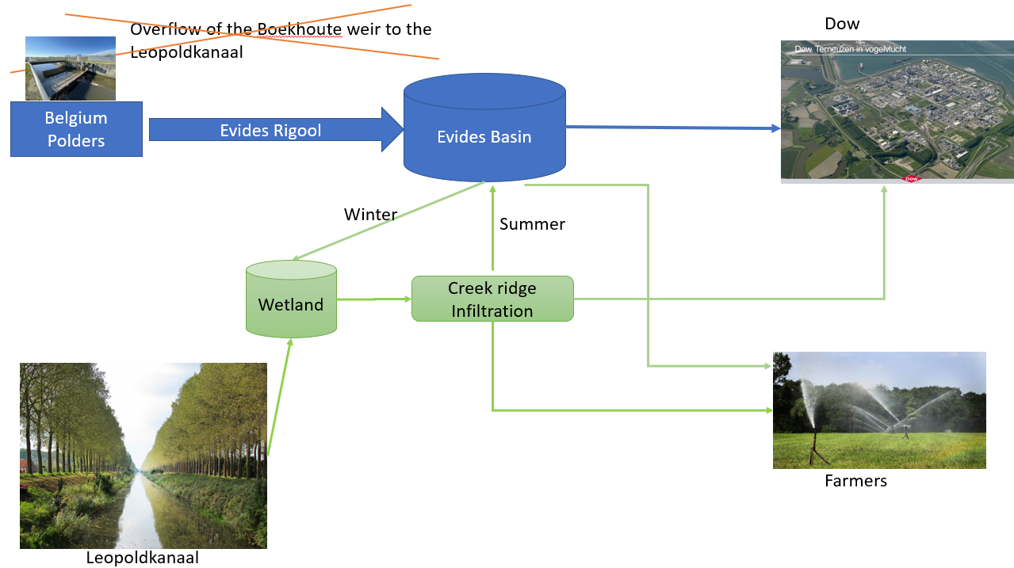

Figure 8: Suggested design for infiltration. Blue is infrastructure already existing and green is the suggested expansion.

# Refferences

Waterschap Scheldestromen. (2019). *Nota Grondwater.* Version db 2 juli 2019. Reg nr. 2019005935. 13 juni 2019

*RIVM Zoeksysteem van stoffen*, Geraadpleegd op 20-06-2022, van <http://rvszoeksysteem.rivm.nl>

*Vlaanderen Waterinfo Kaartencatalogus*, Geraadpleegd op 23-05-2022, van <https://www.waterinfo.be/kaartencatalogus>

Boiten, W., Dommerholt, A. en Soet, M., 1995. Handboek debietmeten in open waterlopen. *Vakgroep Waterhuishouding, rapport 51, Wageningen*

Waterschap Scheldestromen. (2015). *Watergebiedsplan Braakman e.o. Planvorming wateropgave.* Reg nr. 2015033897. 28 October 2015.

Appendix

1. Water quality data



1. Volume over the Boekhoute weir

|  |
| --- |
|  |
|  |
|  |
|  |
|  |
|  |

1. Calculations Volume over Boekhoute Weir

